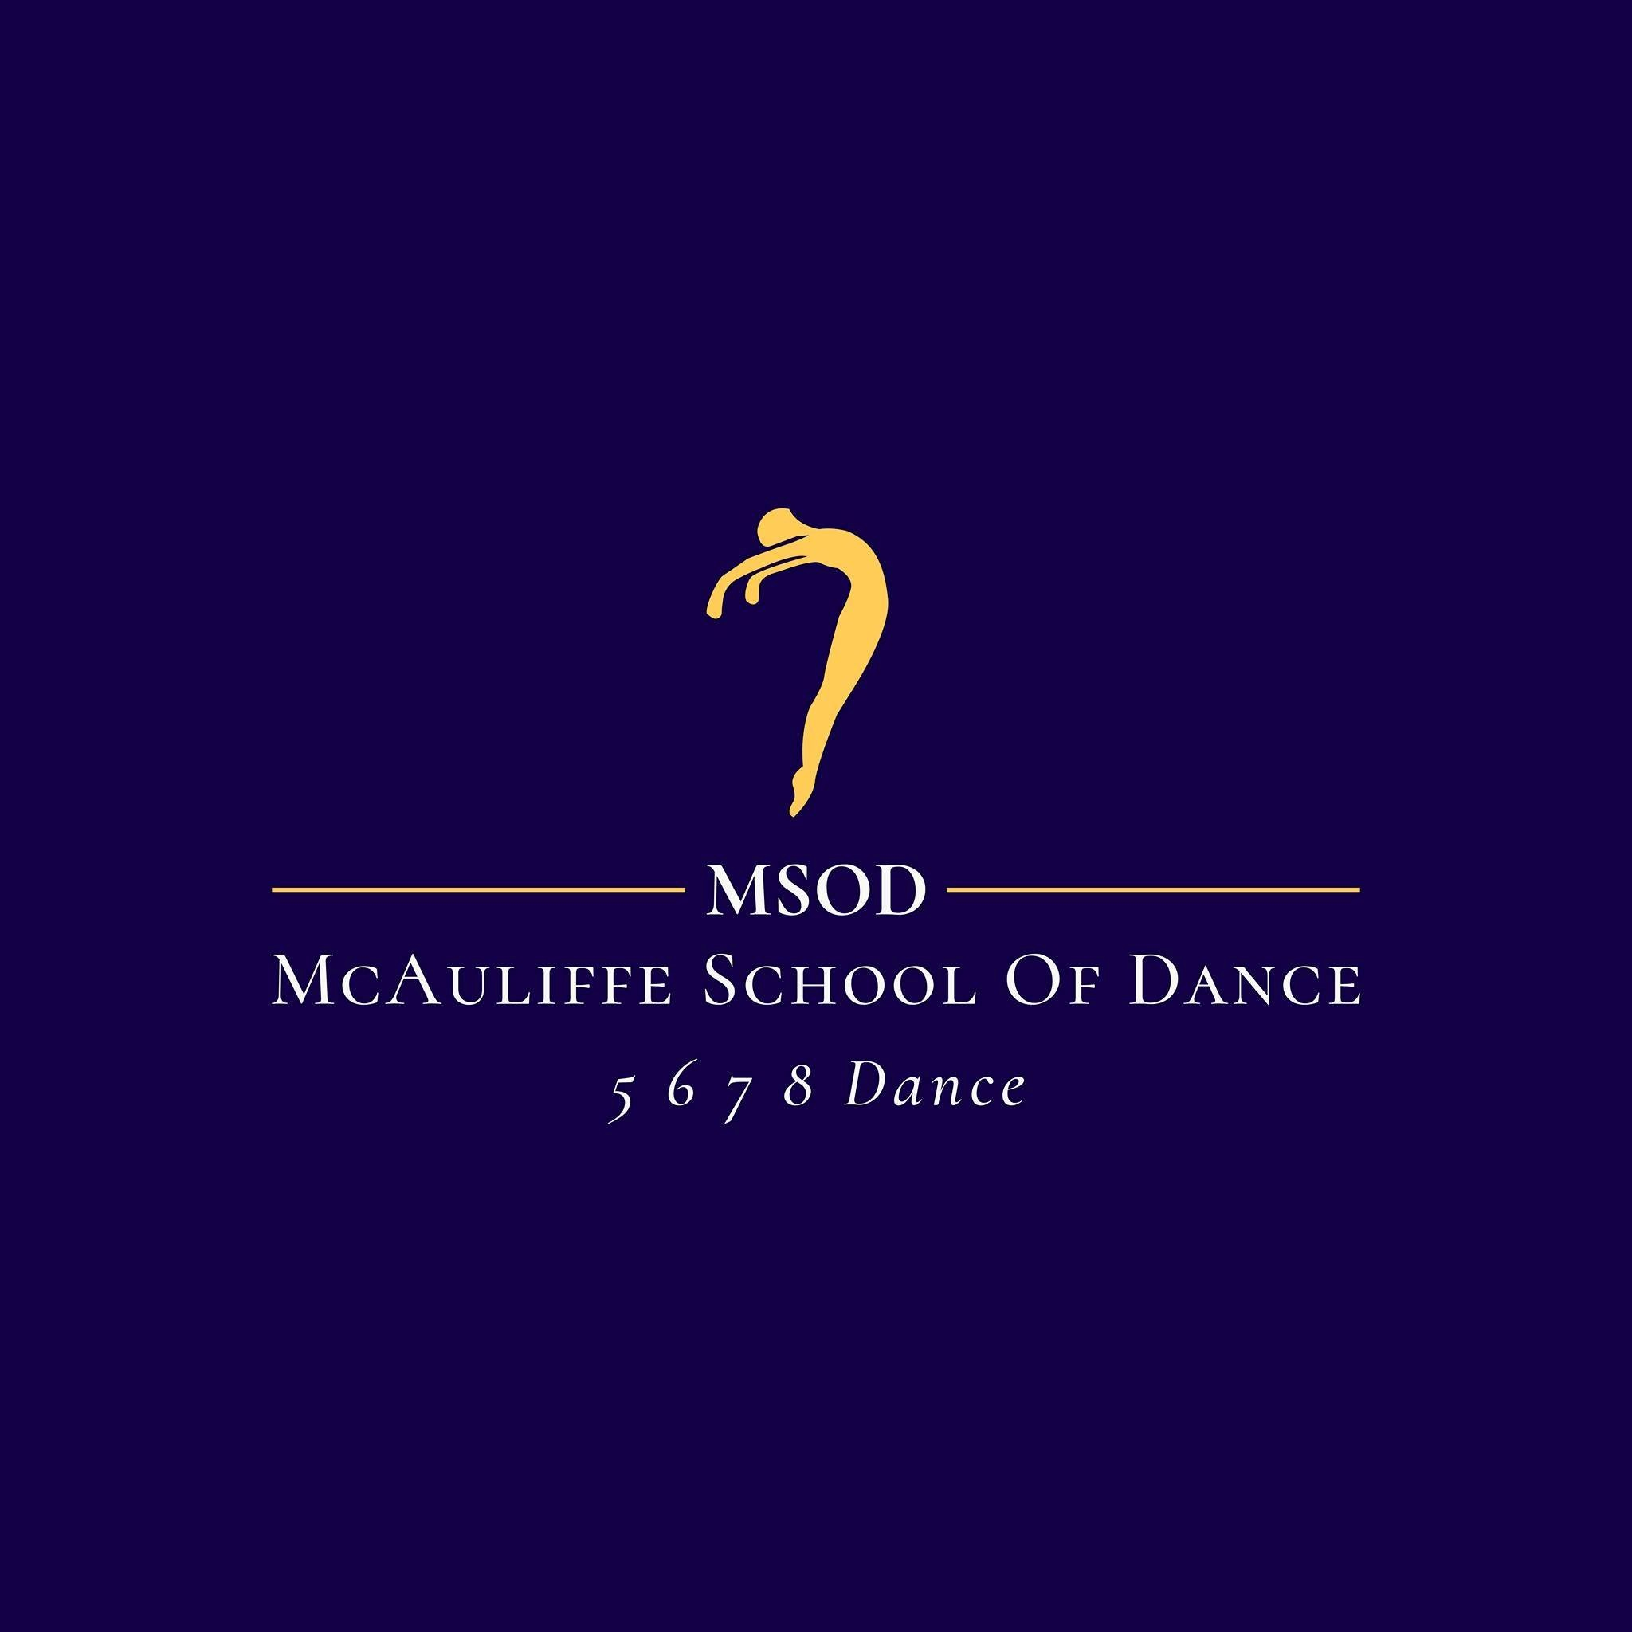
Enrolment
Form
2026
KYOGLE
or
CASINO
Name
of
Student:
Date
of
Birth:
Age
at
1
/01/
26
Name of the person paying the invoice: Payment weekly/1 instalment 1 week after invoiced

Reliable email address for invoices and newsletters:

Phone number:

In Case of Emergency name, number and relationship to student:

Date commencing lessons:

Has danced before?

2026 class choices:
Any medical issues that may interfere with dance classes?

Consent to call an ambulance if deemed necessary if unable to contact a parent or guardian?

Consent to use the students image or videos in promotional material in print, social media and on the website?

Any other information or concerns you wish to share?
I have read the MSOD welcome pack and understand and agree to all terms and conditions of enrolment.
Parent/Guardian Signature………………………………………………………….
Date:…………………………..
$25 Enrolment Fee to be paid to BSB 062-519 ACCOUNT 10275376

